**QuickServe: Streamlining Daily Essential Services for Busy Bachelors**

**Akash Goel1, MD. Faizal2, Manish Kumar Mandavi3, Harsh Choudhary4**

**Dept. of Computer Science, KIET Group of Institution, Delhi-NCR, Meerut Rd, Ghaziabad,**

**Uttar Pradesh 201206, India**

**Abstract *- In today’s fast-paced world, bachelors often struggle with efficiently managing essential services, such as maid, laundry, mess/tiffing services, and general daily services. The main challenges they face include finding reliable service providers, comparing prices, and coordinating bookings, leading to wasted time and subpar experiences. on the other side different types of daily service providers often find difficulty for getting users according to their skills due to communication gap between provider and receiver[1].***

***To address these issues, our research introduces user-friendly web application[4] designed to streamline the process of*** ***discovering, booking, and managing these services  according to their schedule and convenience and also provides a communication channel between service provider and user. A feedback-based rating system can improve reliability of the service provider and improve the service provider skills.***

**I. INTRODUCTION**

Being in the 21st century with the rapid technological advancements and ever-increasing busy schedule of individuals, especially bachelors, often find themselves struggling to efficiently find and manage essential services to daily life. Tasks like maid, cook/chef, grocery shopping, and cleaning, once mundane, have become time-consuming challenges, often resulting in wasted hours, frustration, and subpar experiences[8]. The difficulties lie in the timeless scroll on google to find the right service provider[2]. process of finding reliable service providers, comparing prices, and coordinating bookings, leading to a pressing need for a solution that simplifies and streamlines this experience.

QuickServe platform is presenting a comprehensive and user-friendly solution to the daily challenges faced by bachelors. By leveraging cutting-edge technologies, this research aims to develop a robust responsive web application that revolutionizes the way individuals access and manage essential services the most popular techniques is the responsive Web design. This application does not merely serve as a bridge for connecting users with different service providers as shown in Figure 2. it is a transformative tool designed to enhance efficiency, reliability, and convenience in the daily lives of bachelors.

From its foundational technologies to its user-friendly interface, the research will provide a detailed analysis of the application’s architecture, design principles, and implementation strategies. We will also examine the challenges faced by bachelors in accessing essential services and how the proposed application addresses these pain points. Moreover, this paper will shed light on the project’s impact on user experience, and Quality of service[9].

Based on our work, we have made the following contribution in this paper.

• We have designed a platform which fills the communication gap between the user and service provider.

• Our system can suggest the most suitable service provider to a service receiver according to the location of receiver and provider.

• User can chat in real time with the service provider or generate the enquire request.

• User can do online transaction on this platform via different channels.

• A user feedback or rating system can be helpful for a receiver to evaluate the profile of a service provider.

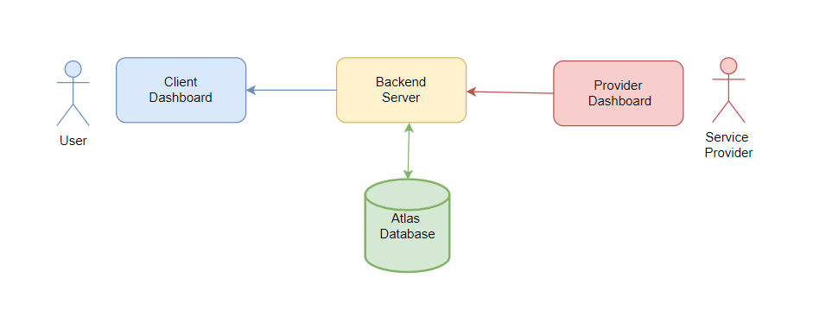

Figure 1:Bridge between user and service Provider

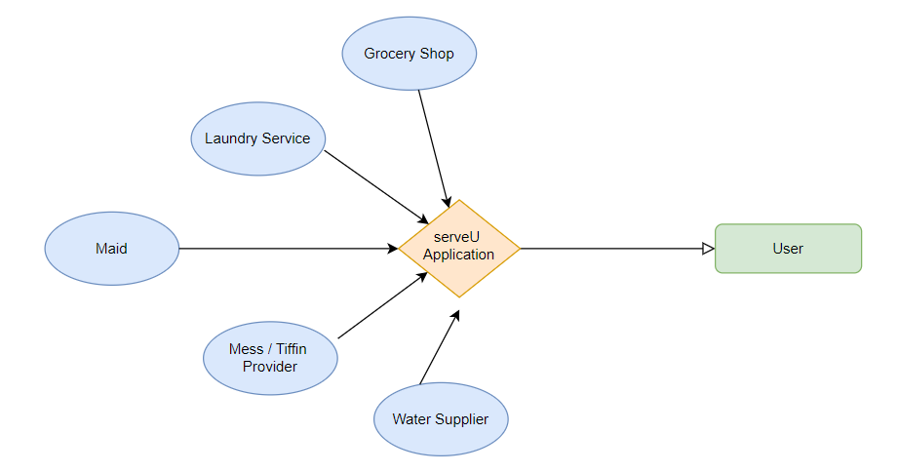Figure 2: Different Service Provider

**II. RELATED WORK**

In order to facilitate this situation various types of online platform introduced like urban Company, Dubba Wala, and Suleka. This has made people's lives much easier than they were previously[2]. But in all these platforms some improvement is require as these platform does not provide the facility to the service provider to connect with user directly.

There are lots of research based on internet marketing. Researchers have delineated various features in this sector. Furrer and Sudharshan have performed their research to find out the scopes and problems in internet-based marketing. They have proposed to develop a framework for finding out the problems standing along the way of successful internet-based marketing.

Service-Hub aims to improve the accessibility and management of daily household services, particularly in third-world countries like Bangladesh[1]. By providing a cost-effective and efficient online service system, it seeks to enhance the lives of both service receivers and providers, with potential applicability in other countries.

Similar work has been done with the Dr. Kiran Bhandari and Karan Dhiman they have developed the A WEB-BASED SERVICE MARKETPLAC[3]. to buy and sell services. Freelancers, private individuals, and corporations from a variety of industries can offer their skills and be hired by those who want their aid.

**III. PROPOSED SYSTEM**

The primary objective of QuickServe is to provide a comprehensive and user-friendly web portal where user can efficiently discover, book, and manage all his daily services at one place. This paper discusses how to establish communication bridge between user and service provider. So that user can efficiently book or manage daily services without any hassle. Service provider will get the request message whenever any user raises the request. Service Provider should get the right user according to his skills and from the same locality. User and service provider can chat with each other in real time.

Every user has to go throw from the user authentication process(user, service provider). If the user wants to create a provider account, he needs to create his provider account after that he can add his services and manage his service listing and service request from his dashboard. Normal user will just search the service what he needs after that according to his location all service provider list comes from that user can compare price as well as rating and review of service provider if he wants to chat or raise a enquire, he can. All raised enquire showed to provider dashboard from there he can reply to chat or give decision of availability.

**IV. SYSTEM DESIGN**

**A. SYSTEM MODELS**

A.1 User Version

Basically, user who want avail the service needs to create the account by entering name, email, and password which will store in the database for the future. After the login process, he redirects to the user dashboard where he can search new service and manage his old services and feedback. If the user wants to search new service, he has to search the service name and then choose the service provider from the list where he can raise the query or message to the service provider. After the query raise system will create a request on the service provider dashboard where he can accept or reject the request according to his availability. User can also give feedback to the service provider.

A.2 Service Provider Version

In the service provider dashboard, he gets lots of functionality like he can see status of all his user request where he can accept or reject his requests. He can reply to the user query from the chat functionality. In addition to this provider has the feature to maintain his service list like he can add, update, or delete his services. Service provider get the message whenever any new customer raises the service request and can read the feedback of user. he can update his user profile whenever he wants.

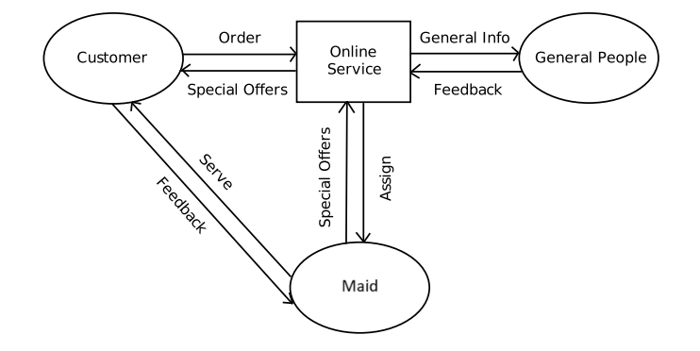

Figure 3: Model Connection

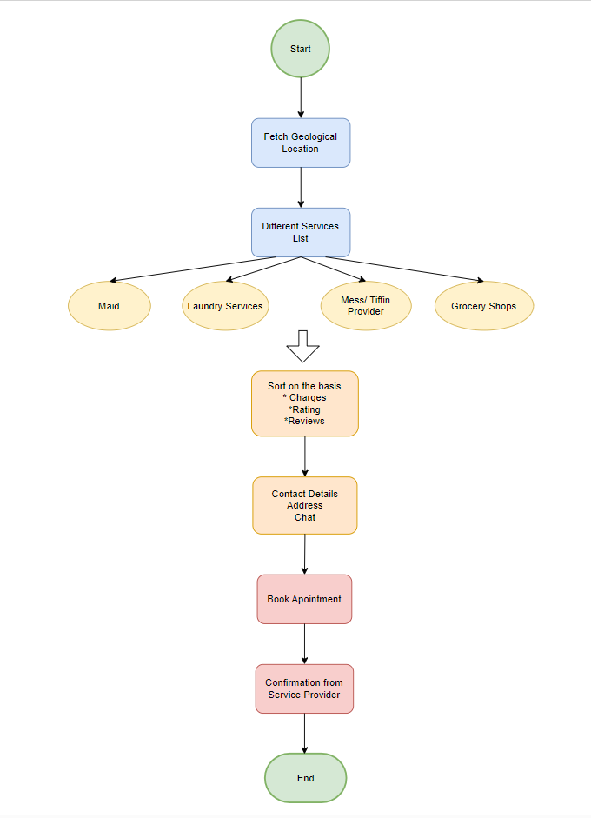

Figure 4: Flow Diagram

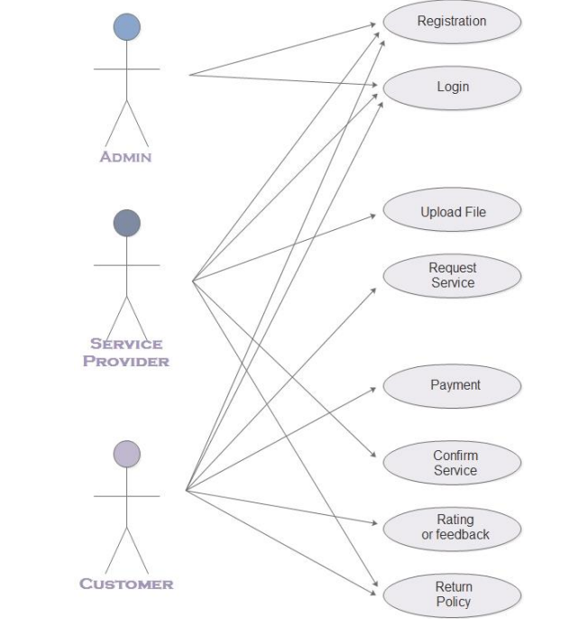

Figure 5: Use Case Diagram

**B. SYSTEM TOOLS**

B.1 React (Frontend)

In this project we have used the react library for the frontend work. It helps us to divide our project in small modules which is easy to manage. Along with this we have used tailwind CSS for styling[7]. This helps us to build the responsive[6] user interfaces like authentication pages, dashboard pages, service listing pages etc. We have integrated these pages with the main app and make a single page web application.

B.2 Express (Backend)

It helps us to create a express server which will handle all the backend tasks like storing all the authentication data to database. It connects the right user with the right service provider. And also handle the chat feature.

B.3 MongoDB Atlas (Database)

In atlas we have added all the user data, provider data, service data, and chat data.

**C. SYSTEM MODULES**

C.1 Authentication Module

This will handle all the authentication tasks like signup and login. If the new user comes it will create new user and after taking the name, phone no, email, and password. And if existing user comes it will login the user to his dashboard.

C.1 User Module

Here user can manage all his service request and his profile. He can also give feedback to his previous service provider. From his dashboard he can chat will the service provider directly or raise the service request whenever he require[5].

C.2 Service Provider Module

Service Provider can see status of all his user request where he can accept or reject his requests. He can reply to the user query from the chat functionality. In addition to this provider has the feature to maintain his service list like he can add, update, or delete his services. Service provider get the message whenever any new customer raises the service request and can read the feedback of user. he can update his user profile whenever he wants.

C.3 Service Listing Module

This will list down all the nearby service provider according to the user need. Where user can compare prices, read user reviews and chat with the provider.

C.5 Chat Module

This enables us to establish two-way communication channel between the user and service provider.

C.6 Payment Module

Through this module customer can pay for the services opted. It is done through an external payment gateway which guarantees a secure and safe transaction. Once the payment is done, a confirmation acknowledgement is forwarded to the user about all the details of services opted and also an onsite confirmation is displayed on the website.

**IV. SYSTEM IMPLEMENTATION**

As a part of our study, we have implemented this application by running on local machine. Most of the original design is based on intuition. we here implemented our primary design followed by the user’s primary household problems. Our primary locations are Mohan Nagar and Murad Nagar and primary service orders are maid, mess and laundry etc.

A. User

When user has created account and login to the website. Figure shows the how landing page shows.

When user search any service, he will get list of all the service provider in his nearby location. Figure shows how the listing page will be shown. if user want to see the provider profile he can see as shown in Figure .

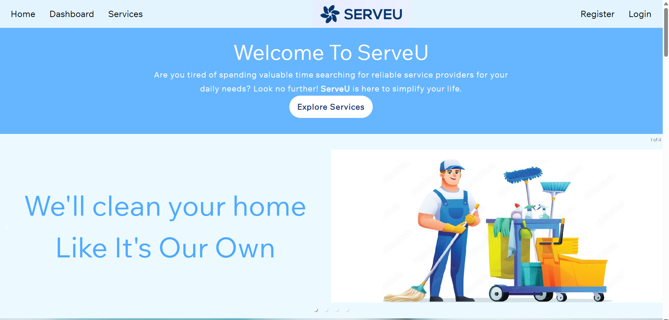

Figure 6: Landing Page

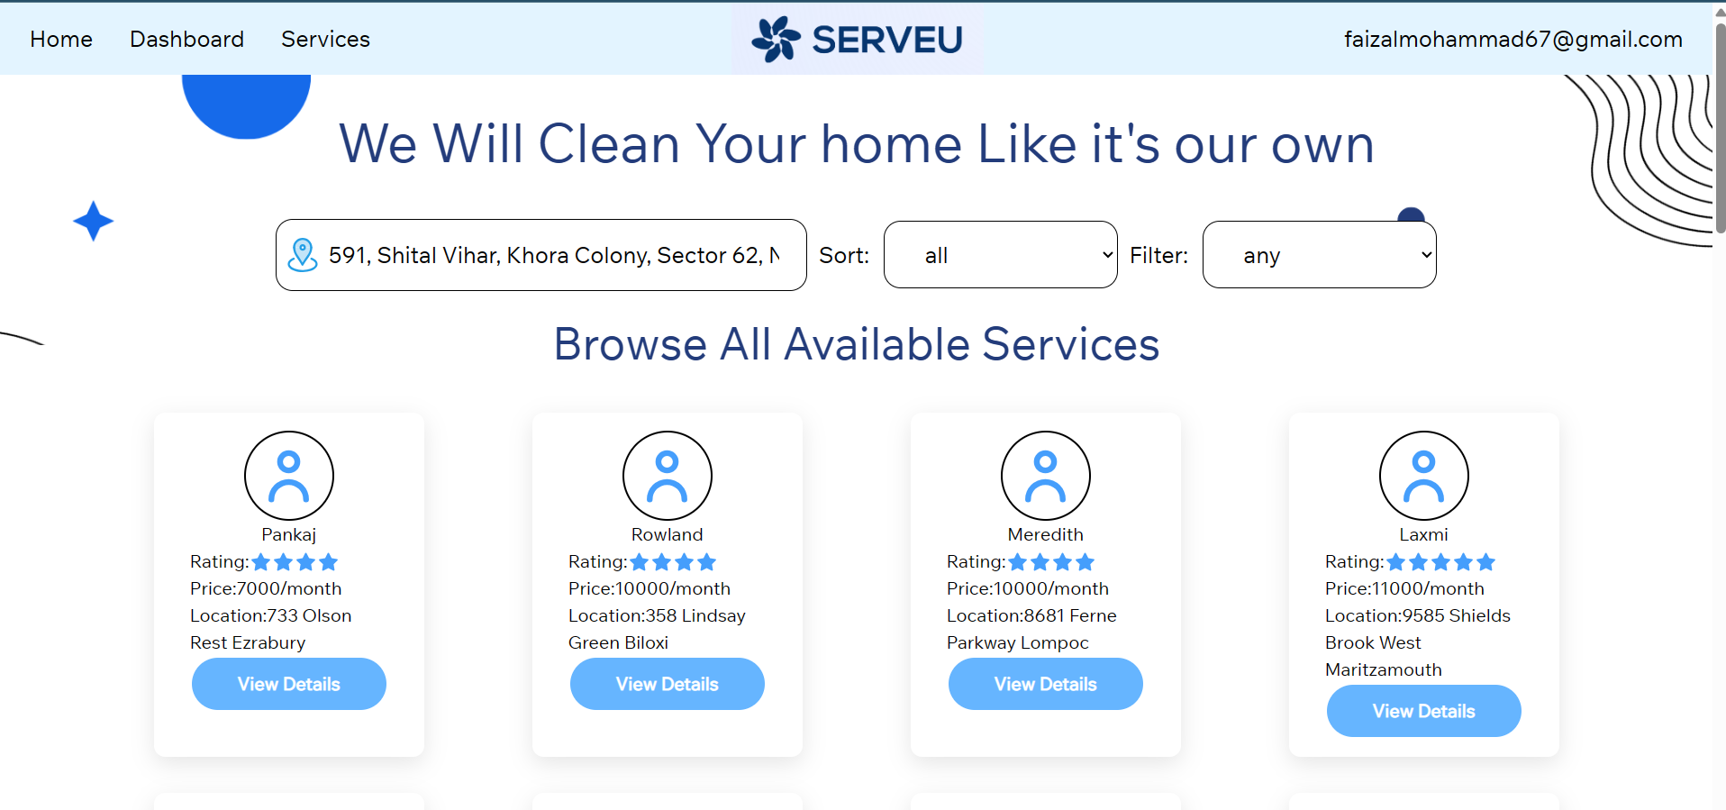

Figure 7: Service Listing page

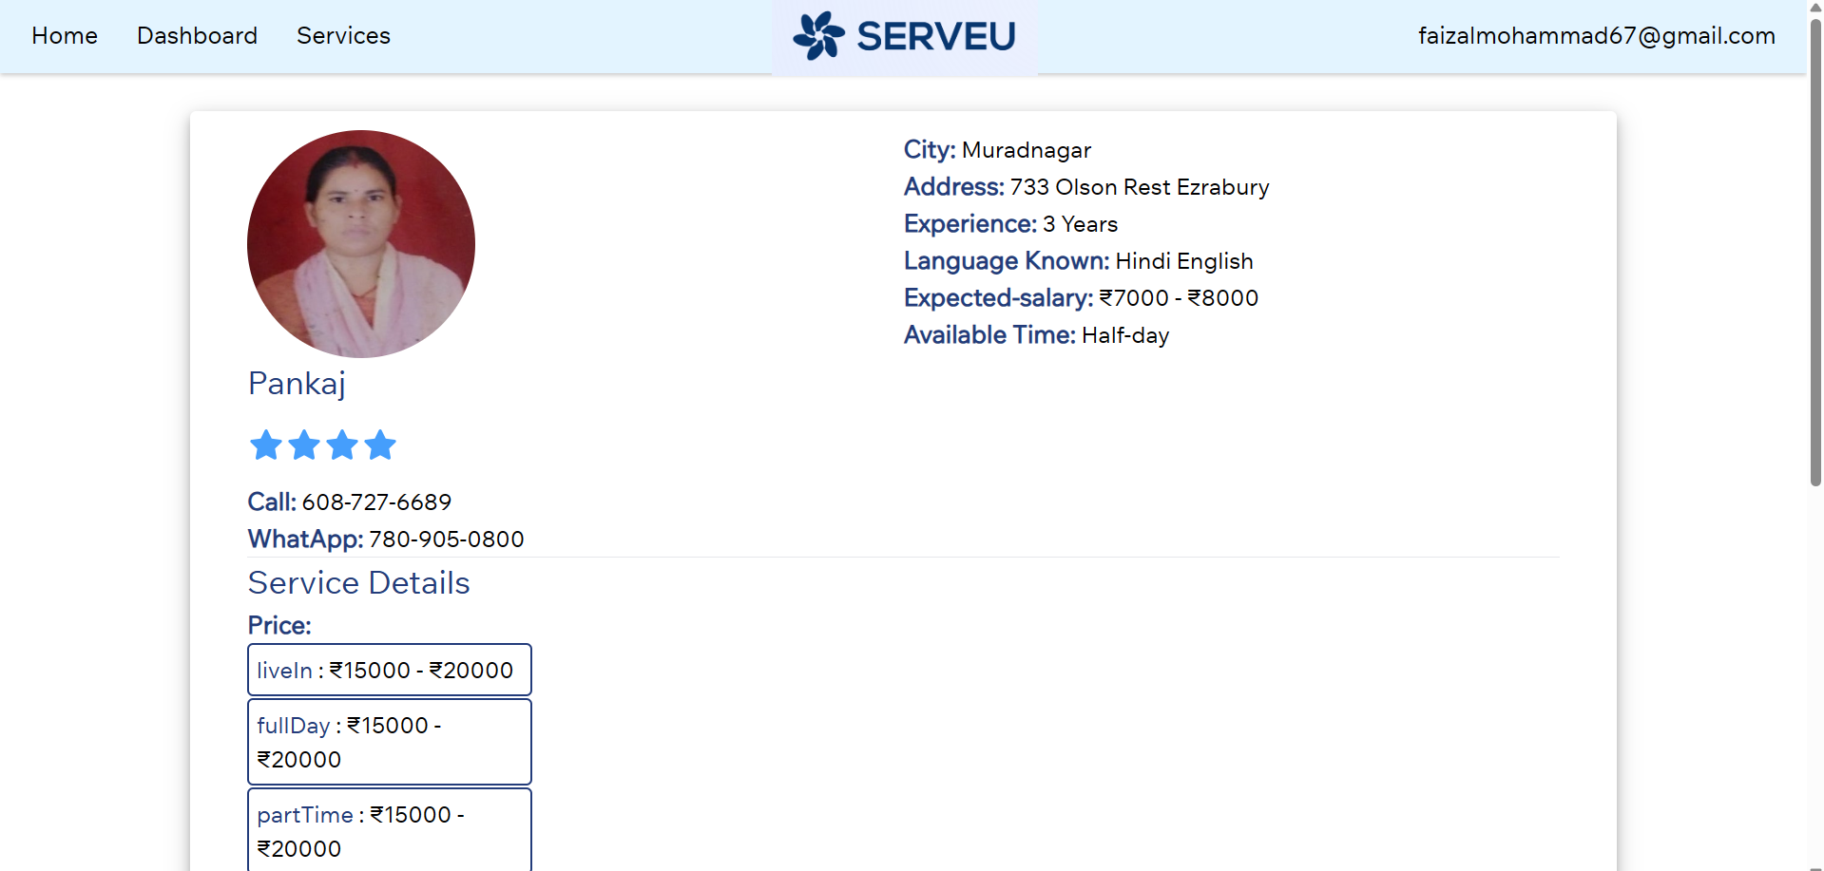

Figure 8: Service Provider profile

B. Service Provider

If the user want to become a service provider he can become after the service registration form as shown in Figure 9 after that he can add different services as Shown in Figure 10 whenever user send request to service provider new request adds into the service requests table as shown in Figure 12 where he can chat with the user with the help of chat popup as shown in Figure 13.

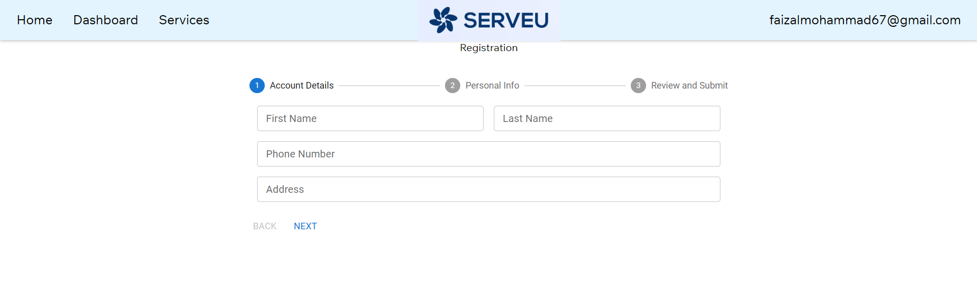

Figure 9: Service Provider Registration

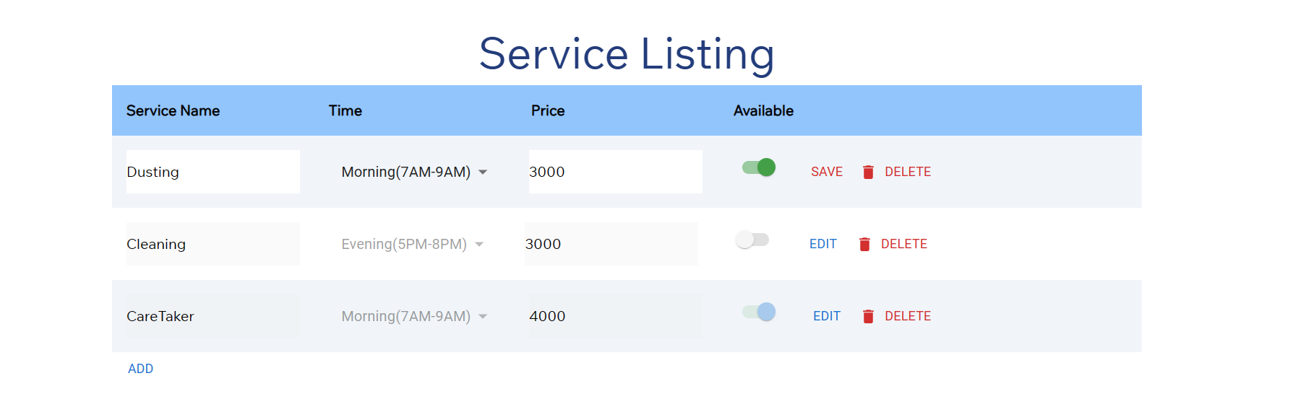

Figure 10: Service listing setting

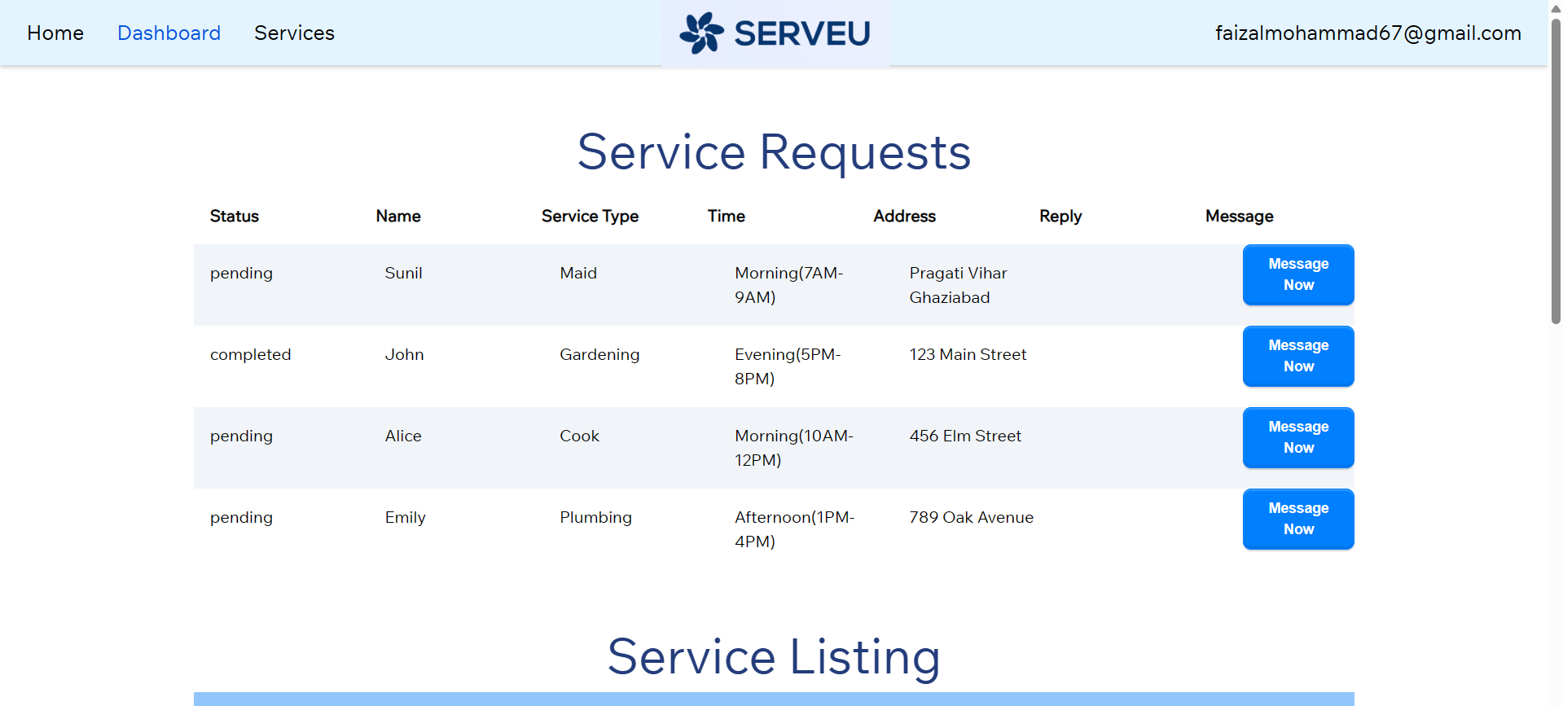

Figure 11: User Service Requests

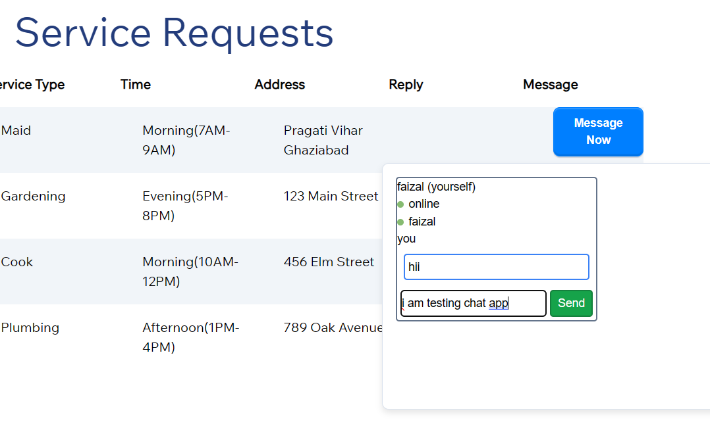

Figure 12: Chat Interface

**V. FEATURES OF PROPOSED SYSTEM**

Our proposed system provides the following features that ensures proper communication between receiver and provider, feedback from users and evaluation of service providers.

• Service Listing: One Platform which show the catalog of all the Nearby essential service Provider such as laundry, grocery shopping, Mess food, and maid services and many more. Included detailed description of pricing, rating, user feedback and service provider information.

• Location Service: Utilize geolocation to help users find nearby service providers. We have used google geolocation API to get the user co-ordinates with the help of this we fetch all the service provider from the same locality.

• Price Comparison: it helps user to compare prices from different service providers, helping users make informed decisions based on cost-effectiveness and quality.

• Booking and Scheduling: Allow users to book services at their preferred date and time. Scheduling system to manage appointments for laundry pickup and drop.

• User Review and Rating: Enable users to leave reviews and ratings for service providers. Which help other to make informed decision.

• Chat and Messaging: messaging system for users to communicate with service providers. It helps to make a two-way communication channel so that user and service provider can send messages in real time. for implementing this we have used Socket.io module. Socket.IO isa library that enables low-latency, bidirectional and event-based communication between a client and a server.

**VI. FUTURE SCOPE**

Some of the most popular home services are available through this application. When new requirements arise, the system as a whole can be built to accommodate them by expanding its capacity, for which the application offers a suitable offshore service. By simply adding the necessary services and extra payment methods, this application may be extended even further. The present system offers several services, including maid, house cleaning, cook and laundry, and mess food. It can also be expanded to meet the specific needs of the customer. The system can be extended by including services like electrician and mechanic repair, fitter, and catering.

**VII. CONCLUSION**

In conclusion, the successful implementation of our user-friendly web application represents a significant milestone in addressing the challenges faced by bachelors in accessing and managing daily essential services. By offering a centralized platform[3] that seamlessly connects users with reliable service providers, we have provided individuals with convenience, efficiency, and peace of mind. The intuitive user interface and smart algorithms ensure swift and hassle-free service discovery and booking, saving valuable time and effort. Moreover, our web app robust review system and stringent verification processes guarantee the reliability of service providers, fostering trust and satisfaction among users. This reliability, coupled with the removal of complexities associated with essential chores, allows bachelors to focus on their personal and professional pursuits, thereby enhancing their overall quality of life and well-being. Additionally, the app has a positive economic impact by supporting local businesses and service providers, thus stimulating economic growth in communities. Our commitment to continuous improvement, through regular updates, user feedback integration, and innovative feature additions, ensures that our application remains relevant and cutting-edge in meeting the evolving needs of users.

**VIII. REFRENCES**

[1] Bhattacharjee, Ananya & Tasnim, Tahrina & Sohel, Md & Chakraborty, Amit & Maruf, Md. Abdullah & Nitun, Shantanu & Ishmam, Alvi & Toha, Tarik & Islam, A. B. M. Alim Al. (2017). Service-Hub: A Better Approach for Developing the System of Online Marketing for Daily Services. 1-5. 10.1109/NSYSS2.2017.8267801.

[2] N. M. Indravasan, Adarsh G, Shruthi C, Shanthi K , Dadapeer, 2018, An Online System for Household Services, INTERNATIONAL JOURNAL OF ENGINEERING RESEARCH & TECHNOLOGY (IJERT) NCESC – 2018 (Volume 6 – Issue 13),

[3] Dhiman, Karan & Phansikar, Mayuresh & Kazi, Mohamed Zain & Thakur, Rutuja. (2022). A WEB-BASED SERVICE MARKETPLACE.

[4] Sarhan, Qusay & Gawdan, Idrees. (2018). Web Applications and Web Services: A Comparative Study. Science Journal of University of Zakho. 6. 10.25271/2018.6.1.375.

[5] Arora, Karishma & Vaishnavi, & Nagpal, Jai. (2023). Implementation of MERN : A Stack of Technologies to Design Effective Web Based Freelancing Applications. International Journal of Scientific Research in Computer Science, Engineering and Information Technology. 23-32. 10.32628/CSEIT23902104.

[6] Almeida, Fernando & Monteiro, J.. (2017). The role of responsive design in web development. Webology. 14. 48-65.

[7] Gurjeet Singh, Madiha Javed, Dr. Balwinder Kaur Dhaliwal (2022). Full Stack Web Development: Vision, Challenges and Future Scope.

[8] Gautam, Indu & Jain, Sameeksha. (2018). A STUDY OF WORK-LIFE BALANCE: CHALLENGES AND SOLUTIONS. Conference: Emerging Role of Leadership, Values and Ethics in Organisational DevelopmentAt: KIET, Ghaziabad.

[9] Gupta, Varun & Saxena, Nitin & Kanungo, Abhas & Salim, & Singh, Gavendra. (2024). An Efficient FrWT and IPCA Tools for an Automated Healthcare CAD System. Wireless Personal Communications. 10.1007/s11277-024-10877-y. Varun Gupta Krishna Institute Of Engineering And Technology | KIET · Department of Electrical and Electronics Engineering.